**Practice Simulation Simulation Practice of ESP32 and Temperature Humidity Sensor (DHT22)**

*Andreika Luna Alghivari*

*Fakultas Vokasi, Universitas Brawijaya*

*Email: andreikaluna@student.ub.ac.id*

**Abstract**

This study focuses on the simulation practice of integrating an ESP32 microcontroller with a DHT22 temperature and humidity sensor to monitor environmental conditions. The ESP32, known for its high performance and wireless connectivity, is paired with the DHT22, a sensor recognized for its precision in measuring temperature and humidity. The simulation aims to demonstrate the process of wiring, programming, and data acquisition using these components. By utilizing the Arduino IDE, the system is programmed to collect real-time environmental data, which can be displayed and analyzed. This practice serves as a foundational step for developing IoT-based solutions in areas such as smart homes, agriculture, and industrial monitoring systems.

*Keywords: DHT22, ESP32, Temperature Sensor, Humidity Sensor, Wokwi, Visual Studio Code, PlatformIO, Arduino.*

**1. Introduction**

* 1. **Background**

The ESP32 microcontroller, with its dual-core processing capabilities and integrated Wi-Fi and Bluetooth, has become a popular choice among developers for IoT projects. The DHT22 sensor, capable of measuring temperature from -40°C to 80°C with an accuracy of ±0.5°C and relative humidity from 0% to 100% with an accuracy of ±2% to ±5%, complements the ESP32 by providing reliable environmental data. The combination of these technologies allows for the development of efficient monitoring systems that can be accessed remotely via wireless communication. Understanding how to wire these components correctly and program them using the Arduino IDE is essential for effective implementation.

* 1. **Objective**

1. Demonstrate the correct wiring and setup of the DHT22 sensor with the ESP32 microcontroller.
2. Develop a simple Arduino sketch that enables the ESP32 to read and display temperature and humidity data from the DHT22 sensor.

**2. Methodology**

**2.1 Tools & Materials**

Wokwi, ESP32, Arduino IDE, and Visual Studio Code.

**2.2 Implementation Steps**

1. Create a new project in wokwi and select ESP32
2. Add the DHT22 and lay out the design
3. Enter the sketch.ino code according to the module
4. Create a new project in platform.io
5. Enter the C++ code in src/main.cpp
6. Edit the platform.ini file according to the module
7. Create a diagram.json file and copy and paste the code from diagram.json into wokwi
8. Create a wokwi.toml file and fill in the firmware code and elf from the copy relative path after compiling the main.cpp file
9. Request license to wokwi.com
10. Start Simulator

**3. Results and Discussion**

**3.1 Experimental Results**

The simulation practice of integrating the ESP32 microcontroller with the DHT22 temperature and humidity sensor was successfully executed, demonstrating the effective functionality of both components in monitoring environmental conditions. Through proper wiring and programming using the Arduino IDE, the system was able to collect and display real-time temperature and humidity data accurately. This successful simulation not only validates the technical capabilities of the ESP32 and DHT22 but also paves the way for further development of IoT-based applications.

1. Diagram.json

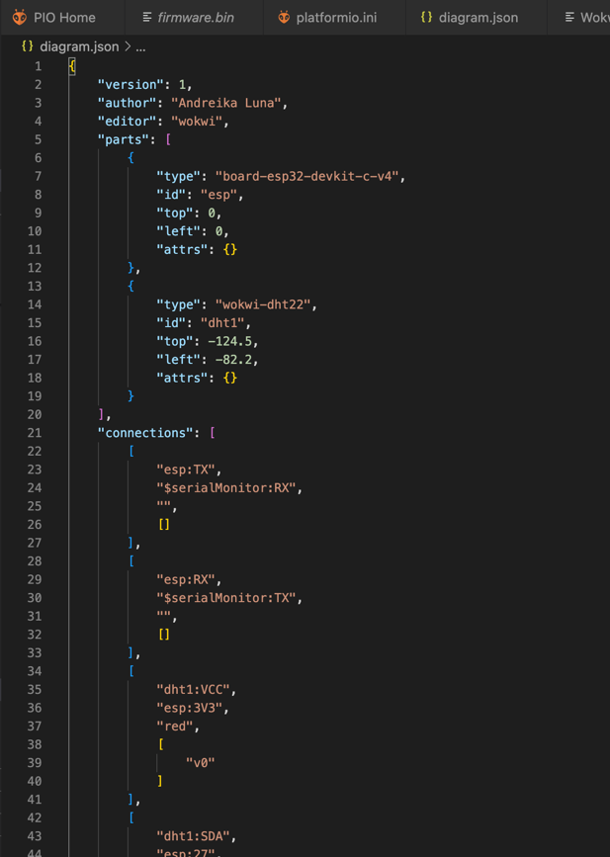

1. Main.cpp

1. Results

